University of Virginia Center for Politics
Civic Engagement: Rebuilding Democracy
Purpose: This lesson plan accompanies the Center for Politics’ documentary, Dismantling Democracy that examines democratic structures of government in the United States and around the world. The film features interviews from across the political spectrum depicts the gradual deterioration of the democratic process. Students will evaluate the current state of democracy across the globe and use that knowledge to propose a civic action plan for their community that will engage citizens in reviving engagement in democratic processes.
Objectives:
Students will identify the characteristics of a strong democracy in order to evaluate health of democracies across the regions of the world.
Students will describe the current status of the current American democratic Republic in order to discuss and debate the need for increased civic engagement and education.
Students will create a Civic Action Plan (CAP) in order to increase awareness of the need for engagement and action in political and civic life.
Materials:
- Article, How Much Danger is American Democracy In? Five Thirty-Eight. January 12, 2021.
Clips from Dismantling Democracy: (Found on: )
PowerPoint: Rebuilding Democracy: What Citizens Can Do!
CAP Template
YLI’s Democracy Corps Program

Vocabulary: Populism Authoritarianism Rule of Law Polarization

Procedure:
- For advanced students: As a warm up, or as a homework assignment the evening before, have them read How Much Danger is America in? from Five Thirty Eight (https://www.fivethirtyeight.com/features/how-much-danger-is-american-democracy-in/) and discuss whether they agree with the political scientists in the article.

Version 2 is a re-written version that is slimmed down and easier to digest for less advanced readers. The concepts are the same so students can examine the key concepts and decide whether from their observations they agree or disagree with the statistics and observations made by the political scientists.

- Break students into groups and give them chart paper, markets. Have them brainstorm a word map of characteristics of a strong democracy. What does that look like? If you were to visit a society with a strong democracy what would you see? (Voting, people speaking freely, etc.) Give students 5-10 minutes to brainstorm those ideas then they should share their ideas with the class. Discuss:
Which characteristics are most important? Least? Why?
How are democracies put at risk? How are they protected?
Can you think of examples of democracies that are or have been extremely healthy? Describe.
Can you think of examples of democracies that are or have been unhealthy? Describe.
How would you describe the American democratic Republic now? Why?
(Use YLI’s Talking Turkey: Taking the ‘Dis Out of Civil Discourse, Rules for Civil Discourse guide for this conversation. Let students really discuss what they see going on in American society. Students could use their technology- phones, tablets and collect headlines from media to describe the state of American democracy. Try to encourage all students to in some way express their thoughts about the health of American democracy. Not all comments will be good or bad. Last election we had higher voter turnout than usual. At the same time, there is a high level of polarization.)

- Have students watch Dismantling Democracy, Segment #1: regions_europe.mp4 (11:09) to identify the problems taking place in Europe and compare that to what we see taking place in the United States. As students are watching they should take notes on the following:
- Why has POPULISM (a political approach that strives to appeal to ordinary people who feel that their concerns are disregarded by established elite groups.) become popular in Europe and around the world?
- What challenges in democracy facing in Europe?
- What must citizens do to promote and protect democracy?
- How do authoritarian leaders get citizens to chip away at democratic freedoms?
- Is the example of Europe similar to that of the United States?
- How do you think European democracies will respond?

If you had to give Western Europe an overall grade for supporting democracy. What grade would you give to Central Europe? Go to www.freedomhouse.org/explore-the-map (use the democracy, internet and global freedom buttons to see how the status changes for countries in Western Europe varies) You can also use the Our Issues link to see what countries Freedom House is focusing on for that issue. The Countries link allows you to enter a country name and find its ranking by global freedom, internet freedom, and democracy score. (It is recommended to use the site prior to students using it to gather familiarity with the material.) Model how to look at the countries in Western Europe and as a class determine a grade for Western Europe.

- Assign students to groups and assign each group to a region.
Africa- regions_ssAfrica.mp4
Asia/Pacific- regions_asiaPacific.mp4
Eurasia-regions_eurasia_mp4
The Americas-regions_theAmericas.mp4
The Middle East- regions_middleEast.mp4
Students should watch the clip for each region and identify the challenges facing democracy in each region. They should visit the Freedom House site and look at the information for the region and then assign a grade for the state of democracy in the region. Each group should be prepared to make a short presentation on the state of democracy with evidence from the documentary and the website. www.freedomhouse.org

- As a class assignment have students discuss what grade they would give American democracy. Give them only several minutes to discuss. Each group should compromise and agree on a grade. Have them share their grade and in ten seconds defend that grade. SET A TIMER.

Now we are going to focus on the United States. Each group is going to look at one aspect of American democracy and assess the health of its democratic Republic. Assign each group one of the following topics:
Voting (money in politics (ep1).mp4), (electoral college (ep.3). mp4)
Media Freedom/Coverage ( free press, entertainment and satire, (ep.3).mp4) (Russian Interference, (ep1).mp4) (Social Media Tunnels and weaknesses, (ep.3).mp4)
Equality (equality principle (ep1).mp4, (exclusionary practices- disenfranchisement (ep.1).mp4), American dream (ep1).mp4.
Polarization hyperpartisanship and civil discourse, (ep.1-3)mp4., otherism (ep.1)mp4., populism
Civic Education civic education (ep.3).mp4, second step to civic engagement, (ep3.)mp4.

Groups can start by viewing the clips from the Dismantling Democracy documentary as a base for their assessment then they should develop a rubric for how they would assign a grade for their topic. What would an “A” country look like? They should have an idea from the previous activity. Once they build their rubric they should use it to interview friends, family, teachers, community members to assess Americans on that topic. Give them time to collect data depending on how far you want to go with the project.

- Bring the data together and jigsaw the groups so that there is a student from each topic in each group. Students should discuss what they learned from their data collection and discuss, debate and come to consensus on a grade for American democracy.

- As an assessment have students re-write the 538 article they previously read, How Much Danger is America In? using information from the lesson and asserting their opinion that America is in either better or worse shape than the author suggested.

- EXTENSION: Using YLI’s Democracy Corps program, and the Civic Action Plan Template begin designing a plan of action for rebuilding the health of democracy in your community. Begin with a visualization activity:

How Much Danger Is American Democracy In? | FiveThirtyEight
JAN. 12, 2021, AT 3:17 PM

How Much Danger Is American Democracy In?
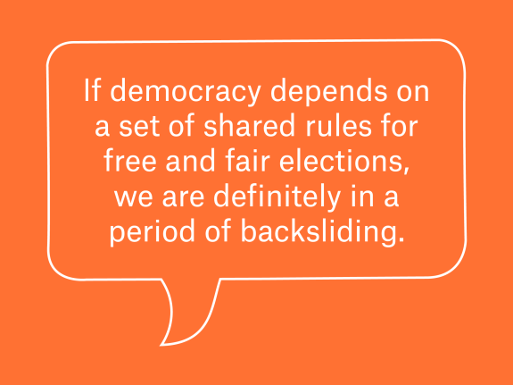

sarah (Sarah Frostenson, politics editor): On Wednesday, a mob of pro-Trump rioters attacked the U.S. Capitol as Congress met to certify the 2020 presidential election results. But as shocking as Wednesday’s events were, they were, in many ways, the culmination of the past four years of Trump’s presidency.
President Trump has long spewed lies to his supporters about the election, refusing until very recently to concede, and routinely has shown his disdain for both the integrity of America’s elections and its tradition of a peaceful transfer of power. And right before the chaos broke out on Wednesday, Trump had just finished urging his supporters to protest Congress’s vote to certify the election results, telling them “[Y]ou’ll never take back our country with weakness. You have to show strength and you have to be strong.” Within an hour, the Capitol was under attack.
This violent episode raises many questions about the future of democracy in America — not only its continued health, but the extent to which the U.S. has already become less democratic. So let’s first unpack this question by diving into this data point: Polls show while the majority of Americans condemn what happened on Wednesday, a plurality of Republican voters support it. What does that say about the current state of democracy in the U.S.?
jennifer.mccoy (Jennifer McCoy, professor of political science at Georgia State University): It shows that Americans are terribly divided over the perception of democracy itself — including whether it is even under threat and who is responsible for the threat. This makes it extremely difficult to propose solutions. But it’s important to keep in mind that we’re talking about 15 percent of the population, maybe 20 percent, who said they condoned the violence.
lee.drutman (Lee Drutman, senior fellow at New America and FiveThirtyEight contributor): Democracy requires parties that are committed to free and fair elections and will accept the outcome — even if they lose. So if the dominant position in the Republican Party is that the only free and fair elections are those where Republicans win, and anything else is “stolen” and fraudulent, then we’re on the precipice of not having a democracy.
But as Jennifer said, the one silver lining here is that the overwhelming majority of Americans reject the anti-democratic rhetoric of Trump and his allies. This is important.
cyrus.samii (Cyrus Samii, professor of politics at New York University): I find it helpful to place this moment in a broader historical context, as I think there are two trends at play here. First, decades of mobilization and a fight for a more democractic, inclusive society have brought about generational changes in America’s politics, including more women, people of color and other long-excluded groups now having a seat at the table. That has made our politics more inclusive and more democratic, but there is a second trend here — a politics of resentment that cannot tolerate this growing diversity. This mindset is particularly rampant within the Republican Party, and part of what CNN’s Van Jones has called a “whitelash,” or conservative white Christian Americans mobilizing against the type of progress embodied by President Barack Obama’s time in office. The Atlantic’s Adam Serwer has also written on the pendulum swinging between moments of progress on inclusion and white resistance.
Last Wednesday embodied this dynamic in the span of a few hours: We had the historic election of two Democratic senators in Georgia, followed then by a mob, including a number of white supremacists sacking the Capitol in the name of Trump, and most Republicans to date being unwilling to do much about it.
[Storming The U.S. Capitol Was About Maintaining White Power In America]
jennifer.mccoy: Yes, and I think the question now is whether this unwillingness to condemn the mob, or call out their colleagues who are perpetuating the myth of a “stolen election,” is the dominant position in the Republican Party or only a faction that can be contained.
sarah: Do we have a sense of what is driving these attitudes?
jennifer.mccoy: The politics of resentment, written about by a number of scholars, including Kathy Cramer and Arlie Hochschild, who wrote definitive books on the topic, derives from perceptions of unfairness or injustice that accompany the diversification of one’s workplace or community, changing the power structures that Cyrus spoke about. The urban-rural divide in America’s politics exemplifies this. Rural Americans, mostly Republicans, perceive urban dwellers, more Democratic and more racially diverse, as receiving more than their “fair share” of tax revenues and opportunities. With wage stagnation and the growing service-based economy, white males without a college degree, in particular, feel a loss of social status that can lead to rage and support for more authoritarian politics. This is why “identity politics” are arguably more of an issue for the GOP than the Democratic Party today. What’s particularly troubling here, though, is that the political rhetoric from politicians and media personalities are really whipping up latent attitudes of resentment to create the politics of outrage we saw on display last Wednesday. Republicans have gone further than Democrats in using vilifying language and painting horrific scenarios if the “radical, liberal, socialist Democrats” and their “anarchic mobs” take over.
lee.drutman: To follow up on Jennifer’s point about politicians driving some of this, take what Vice President Mike Pence said at the Republican National Convention this summer. He said that the election was about “whether America remains America.” Those are incredibly high stakes, so when you add that kind of rhetoric to our winner-take-all election system, you have a recipe for a very angry minority convinced that the system is rigged against them. As we saw last Wednesday, one response is to take matters into their own hands through violence.
We also know that opposition to democracy is much stronger among Republicans who have beliefs that political scientist Larry Bartels has called “ethnic antagonism,” a measure of “unfavorable feelings towards Muslims, immigrants and other out-groups … [and] concerns about these groups’ political and social claims” in his research.
The chart below is extremely striking as it shows that among Republicans, the higher the level of ethnic antagonism, the more likely they are to say they don’t trust election results, use force as an alternative and support authoritarian stances. (Bartels “normalizes” the distribution so that half of Republicans are above zero on the ethnic antagonism scale, and then presents the data two ways — using statistical analysis to estimate values (left) and reporting the actual data in the limited survey sample (right).) Overall, though, the takeaway is clear: Bartels finds troublingly high support for these sentiments among Republicans.

sarah: Is what happened Wednesday, then, a somewhat expected consequence of what happens when a sizable portion of the electorate loses faith in our elections and institutions?
jennifer.mccoy: To be clear, the research we have doesn’t necessarily show that losing faith in elections and institutions leads to violence. It can, for instance, have repercussions like withdrawal and political apathy. We saw this in Venezuela when the opposition cried fraud, without evidence, after losing a referendum to remove President Hugo Chávez in 2004. They had trouble turning out supporters in governor elections right after, and then called for a boycott in the 2005 legislative elections, handing total control to Chávez’s party and enabling them to name loyalists to all of Venezuela’s political institutions. It took another decade before Venezuelans could mobilize to win back the legislature, but by that time, Chávez’s successor had turned even more authoritarian and remains in power today.
However, if political rhetoric is drumming up violence, using demonizing and dehumanizing language and glorifying battle language, then yes, supporters are likely to engage in violence, thinking their leaders are urging that, as we saw last Wednesday.
[Related: How Trump Changed America]
lee.drutman: Jennifer’s point about political rhetoric is extremely important. The level of nativism, or anti-immigration sentiment, has been roughly consistent in the population for a while now. But there are signs that it has become a much stronger partisan issue in the last decade or so as Trump and other Republicans have played with rhetorical fire. It’s true that far-right leaders have been stoking this issue in multiple western democracies, and as the chart below shows, it’s evident among Republicans in the U.S.
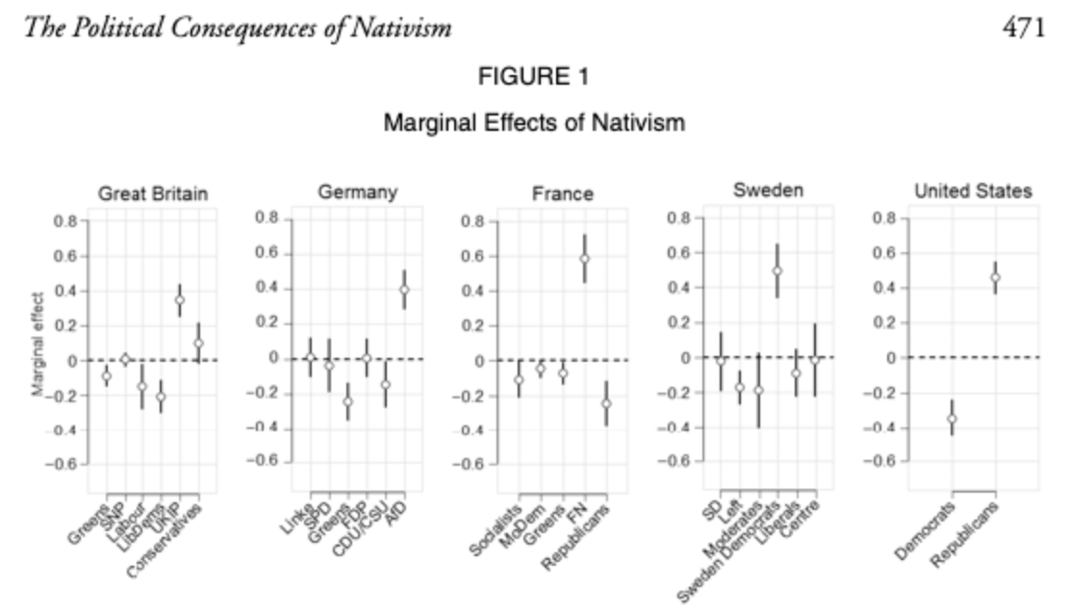
jennifer.mccoy: And the future of the Republican Party is absolutely key to what happens to U.S. democracy. Early signs after Jan. 6 are not encouraging — the party reelected Trump’s hand-picked candidates for the RNC, chair Ronna McDaniel and co-chair Tommy Hicks, and many party leaders have also avoided calling for any accountability for Trump, instead saying that this will further divide the country when we need to unify.
sarah: Some historians have argued if there isn’t accountability, this will all escalate. Is that accurate? How are you all thinking about the importance of consequences for what happened Wednesday for democracy moving forward?
cyrus.samii: If there is no accountability, then the lesson for Republicans will be that they can continue to use illiberal means to maintain a grip on power. And on the left, this might play into the hands of those who would say there is no point in sticking with liberal institutional processes when the other side doesn’t. A clear recipe, in other words, for escalation.
jennifer.mccoy: And if there isn’t any accountability for what happened Wednesday, it gives organized citizens, as well as the next generation of political leaders, license to engage in the same — or worse. Political learning is a real thing, and it can be positive or negative.
If Congress or others fail to act, the road remains open to Trump (and anyone else) to continue to act with impunity, run for office again or support future violent acts. Congress has the ability to impeach Trump and take the extra step of disqualifying him from running again, and the power to censure and even expel the members of Congress who spread the same disinformation about the election and voted against the certification of results in two states. This is important because failing to condemn the exclusionary and hate-filled rhetoric Trump used in his presidency means that catering to the fears, anxieties and resentments of a portion of the electorate might remain a viable political path moving forward.
sarah: Let’s take a step back. In November, The New Yorker’s Andrew Marantz wrote a feature on how civil resistance can stop authoritarian-style leaders from cementing their power, comparing what’s happened in the U.S. under Trump to other parts of the world. “In the past 15 years, there has been a marked global increase in what international relations scholars call ‘democratic backsliding,’” wrote Marantz, “with more authoritarians and authoritarian-style leaders consolidating power.” To what extent is there democratic backsliding in the U.S.?
lee.drutman: If democracy depends on a set of shared rules for free and fair elections, we are definitely in a period of backsliding.
cyrus.samii: I don’t know, the term “democratic backsliding” is problematic in my opinion insofar as it fails to clarify how the conflict in the U.S. is between those using democratic means to achieve progressive change (and succeeding at some moments) versus those who want to push back against that change by undermining democracy. The fact is, a lot of progress is occurring through the ballot box, the U.S. Senate runoffs in Georgia being a prime example, and this is precisely why Republicans are intent on throwing up obstacles to its broad-based use. Republicans have been trying to disenfranchise minority voters, for example, and these efforts are subject to heated legal fights.
sarah: So as Cyrus said, democratic backsliding may be too toothless of a term, but how would we describe the trajectory of democracy in the U.S.? Are we less democratic than one year ago? Four years ago?
[Do Americans Support Removing Trump From Office?]
jennifer.mccoy: According to international rankings, U.S. democracy is eroding faster than what we see in other major western democracies — it is more on par with Brazil, Bangladesh, Turkey and India, according to the global think tank V-Dem Institute’s 2020 democracy report. The Economist Intelligence Unit also downgraded the U.S. to a flawed democracy in 2016. Expert surveys of political scientists, such as Bright Line Watch and Authoritarian Warning Survey, also measure higher threats.
Each of these groups measure democracy using different measures — electoral integrity, rule of law, media and academic freedom, civil liberties, to name a few. But one measure I want to zoom in on is “toxic polarization” (which I call “pernicious polarization” in my research with Murat Somer), as we’ve found it’s especially delegitimizing and on the rise. Essentially, it’s when society is divided into two mutually distrustful camps and there is increased demonization and delegitimization of opponents. Our research has found that it can often result in calls to violence, too.
It’s also something V-Dem uses in its assessments. It found in a 2020 paper that the Republican Party was on par with autocratic parties in Turkey, India and Hungary on their new illiberalism index, especially in their use of demonizing language to describe political opponents, disrespect for fundamental minority rights and encouragement of political violence.
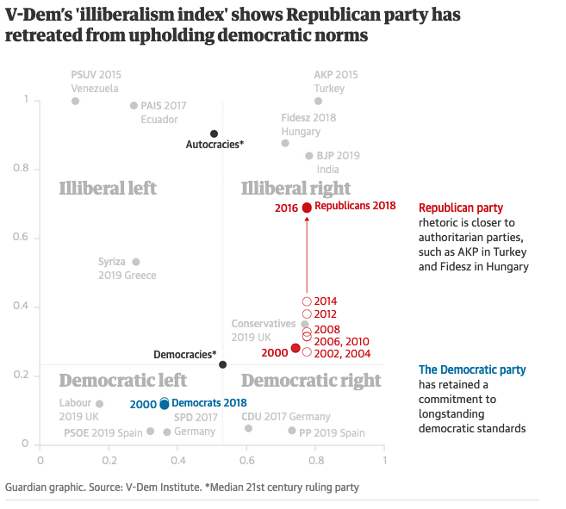
lee.drutman: (If you’re interested in how these various surveys evaluate the quality of a country’s democracy, here’s a great paper that outlines the different ways they measure democracy — summary table below.)
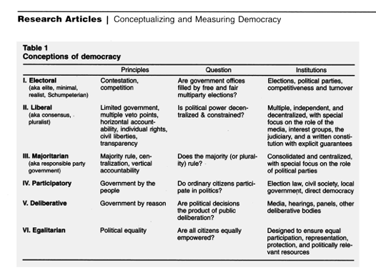
sarah: It’s true that in survey after survey, Republicans, as you all have said, have expressed less support for democracy than Democrats, but I was hoping we could unpack a little more the debilitating effect that this has had on American democracy writ large.
For instance, in the wake of the protests in Portland, Oregon, last summer, FiveThirtyEight’s Maggie Koerth and contributor Shom Mazumder found evidence of members of both parties holding anti-democratic views.
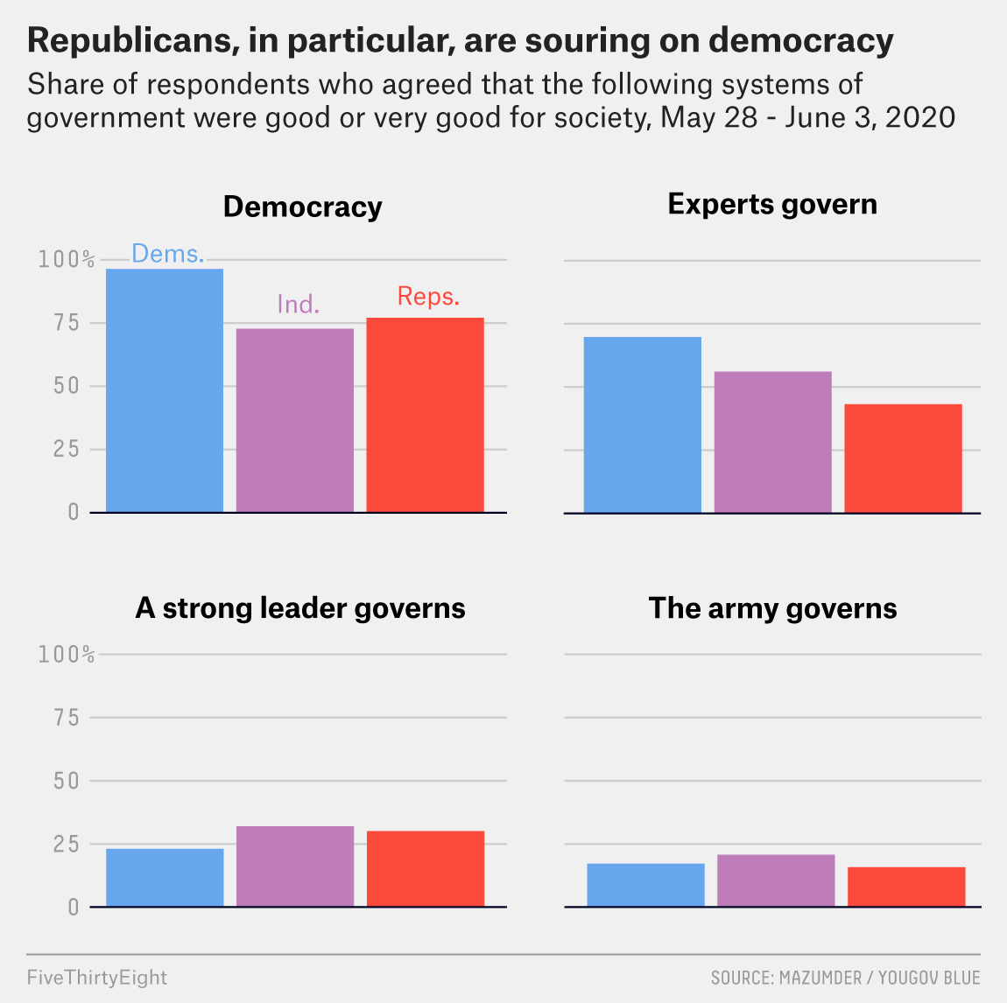
As the chart illustrates, this was especially true among Republicans, so I’m not trying to “both sides” this, but I do want to unpack the effect that severe polarization might have on democratic erosion. That is, how do you factor in polarization when looking at how the U.S. has become less democratic? Is it the number one factor driving what we’re seeing? Or is that too simplistic?
cyrus.samii: Breakdown by party is exactly the right way to look at it. Democrats are involved in a bottom-up struggle to broaden political inclusion while Republicans have been fighting to limit that, including in this past year’s elections. And so it is not so much a question of democratic backsliding at the country level, but rather in terms of whether parties see themselves as being competitive democratically or whether they need to use anti-democratic strategies to maintain their grip.
lee.drutman: Jennifer’s work on pernicious polarization is incredibly important here, and has really influenced my thinking. When politics becomes deeply divided in a binary way along cultural and identity lines (as it is now in the U.S.), democracy is in a really dangerous place.
jennifer.mccoy: And this type of polarization is more likely to lead to democratic erosion because it is based on an “us vs. them” division, not just disagreement on issues.
lee.drutman: On that chart, Sarah, showing support for strong leader/army rule, I’ve co-authored two recent reports on the topic, one in 2018 and another in 2020. And it’s true, we did find some support for these alternatives to democracy on both sides, which is worrying. But again, the overwhelming majority of Americans are in support of democratic institutions.
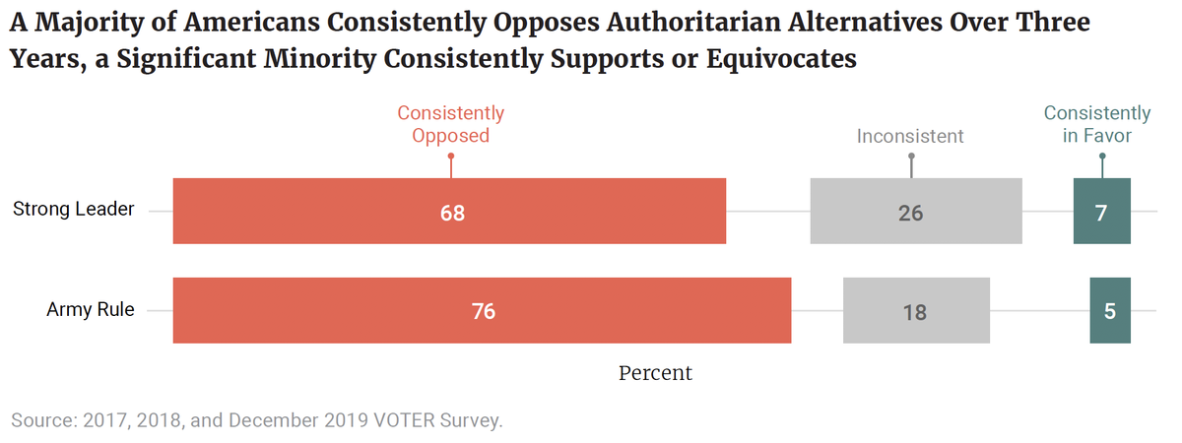
But here is where political leadership is so important. That some voters have weak connections to democracy is not a new problem. In fact, research has found that is typical among those who are the least educated and least politically engaged. The new problem is having political leadership that encourages and stokes these anti-democratic sentiments.
jennifer.mccoy: And as partisan antipathy grows, perceptions of out-party threat grow, and that leads people to challenge democratic norms so as to keep their own party in power and keep the others out.
cyrus.samii: The way I interpret the question, Sarah, is: How does polarization affect Republicans’ thinking on whether or not to abandon the strategy of limiting democratic processes to retain their hold on power, rather than seeking new coalitions, broadening their appeal and making themselves more competitive democratically?
In other words, it’s all about the strategy that the Republicans pursue. So when you take that into consideration, increased polarization — by which I mean distancing oneself from and dehumanizing outgroups — could sustain Republicans’ fixation on limiting democracy because they cannot see themselves forming any new alliances with people outside their traditional white Christian base.
[Could Social Alienation Among Some Trump Supporters Help Explain Why Polls Underestimated Trump Again?]
lee.drutman: Cyrus — that is the central question, but I think there is a significant division among Republicans. So let me reframe your question slightly: What will it take for Republicans who want to build a more inclusive, pro-democracy party to triumph over those who are committed to ethnonationalism and grievance?
cyrus.samii: Yes, Lee, exactly.
lee.drutman: And as long as we think of this as a zero-sum Democrats vs. Republicans fight, we’re stuck. But if we think of this in terms of the forces of democracy vs. the forces of ethnonationalism (or whatever you want to call it), I do think we can make some progress.
sarah: Are there institutional changes (abolishing the Electoral College, reforming the Senate, etc.) that would bolster American democracy or make it less vulnerable to similar challenges in the future?
lee.drutman: I’ve written a lot about what would happen if the U.S. moved to a more proportional voting system, and I do think that would enable a center-right party to operate independent of a far-right party. It also might allow for a broader governing coalition that could keep the far-right out of government, as has happened in many Western democracies with more proportional voting systems.
And maybe we see this play out a little in the U.S. That is, I could see a pro-democracy faction within the Republican Party joining with Democrats to support electoral reforms (such as the Fair Representation Act, a piece of election reform legislation that would establish multi-member districts with ranked-choice voting).
cyrus.samii: Institutional changes to the Electoral College or the Senate would certainly make a difference, since those institutions are a part of what Republicans currently rely on in the anti-democractic aspects of their strategy. But changing them is probably too hard, politically.
Of course, once, say, Texas goes blue, those institutions will come to have the opposite effect and lock out Republicans — unless they change who they can attract. Also, Sarah, I think the idea that “overall trends point to increased illiberalism” is only true when it comes to the kinds of strategies that Republicans are using to try to maintain a grip on their power, rather than with respect to U.S. democratic politics as a whole.
lee.drutman: Yes, changing the Electoral College or the Senate would require constitutional amendments. Enacting proportional representation, interestingly enough, is entirely within Congress’s power, though.
jennifer.mccoy: I want to go back to an earlier point about HOW we get here. I’ve written with Somer about how democracies could solve this dilemma by “repolarizing” along democratic lines vs. authoritarian lines, and what we found is very similar to Lee’s and Cyrus’s point about inclusive movements vs. exclusionary ethnonationalist movements. That is, shifting the axes of polarization to the principle of protecting democracy instead of a divide between different partisan and social identities could actually help protect democracy, as long as it’s not done with demonizing or hyperbolic language.
And that’s important, because as political scientist Daniel Ziblatt has written, a principled conservative or center-right party is essential for a functioning democracy. Even President-elect Joe Biden has reiterated the need for a Republican Party for the health of our democracy. The problem is our two-party system is currently mired in toxic polarization and so the extreme elements within the parties are amplified. We need institutional reforms to allow for political incentives to change.
lee.drutman: I do think the events of Jan. 6 have been a tremendous wake-up call to many on the urgency of democracy reform.
cyrus.samii: It certainly was a wake-up call, Lee. I also think that the incredibly tumultuous times that current 18- to 35-year-olds have endured — 9/11, the Iraq War, the Great Recession, Trump’s presidency, the events that inspired the Black Lives Matter protests this summer, and of course, COVID-19 — could generate a political consciousness that we haven’t seen since the 1960s or 70s.
lee.drutman: Cyrus — yes, there are lots of similarities to the Great Society Era which was the last era of major democracy reform and included major voting rights reform. There are also lots of similarities to the Progressive Era, which was the previous era of large-scale democracy reform.
So if you believe in political scientist Samuel Huntington’s theory that there is a 60-year cycle of democracy reform movements — that every six decades or so, American democracy falls short of its democratic ideals and reform movements emerge to expand our democracy, we’re right on schedule.

Sarah Frostenson is FiveThirtyEight’s politics editor. @sfrostenson
Lee Drutman is a senior fellow in the Political Reform program at New America. He’s the author of the book, “Breaking the Two-Party Doom Loop: The Case for Multiparty Democracy in America.” @leedrutman
Jennifer McCoy is Professor of Political Science at Georgia State University. She is the co-editor of “Polarizing Polities: A Global Threat to Democracy.”
Cyrus Samii is associate professor of politics at New York University. He is co-author of the book “Diversity, Violence, and Recognition,” and executive director of the Evidence in Governance and Politics network. @cdsamii

